* Making Routing Scalable
  + Our routing study thus far - idealized
    - All routers identical
    - Network “flat”
      * … not true in practice
  + Scale: with billions of destinations
    - Can’t store all destinations in routing tables
    - Routing tale exchange swamp links
  + Administrative Autonomy
    - Internet = network of networks
    - Each network admin may want to control routing in its own network
* Internet approach to scalable routing
  + Aggregate routers into regions known as autonomous systems” (AS aka domains)
  + intra-AS routing
    - Routing among hosts, routers in same AS (“network”)
    - All router sin AS must run same intra-domain protocol
    - Routers in different AS can run different intra-domain routing protocol
    - Gateway router: at “edge” of its own AS, has link(s) to router(s) in other AS’es
  + inter-AS routing
    - Routing among AS”es
    - Gateways perform interdomain routing (as well as intra-domain routing)
* Interconnected ASes
  + 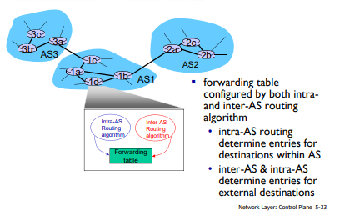
  + forwarding table configured by both intraand inter-AS routing algorithm
  + intra-AS routing determine entries for destinations within AS
  + inter-AS & intra-AS determine entries for external destinations
* Inter-AS tasks
  + suppose router in AS1 receives datagram destined outside of AS1:
    - • router should forward packet to gateway router, but which one?
  + AS1 must:
    - 1. learn which dests are reachable through AS2, which through AS3
    - 2. propagate this reachability info to all routers in AS1 job of inter-AS routing
  + 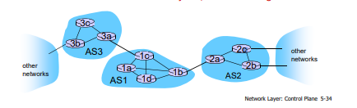
* Intra-AS Routing
  + also known as interior gateway protocols (IGP) most common intra-AS routing protocols:
  + • RIP: Routing Information Protocol
  + • OSPF: Open Shortest Path First (IS-IS protocol essentially same as OSPF)
  + • IGRP: Interior Gateway Routing Protocol
* OSPF (Open Shortest Path First)
  + “ open ”: publicly available
  + uses link-state algorithm
    - • link state packet dissemination
    - • topology map at each node
    - • route computation using Dijkstra’s algorithm
  + router floods OSPF link-state advertisements to all other routers in entire AS •
    - carried in OSPF messages directly over IP (rather than TCP or UDP
    - • link state: for each attached link I
  + S-IS routing protocol: nearly identical to OSPF
* OSPF “advanced” features
  + security: all OSPF messages authenticated (to prevent malicious intrusion)
  + multiple same-cost paths allowed (only one path in RIP)
  + for each link, multiple cost metrics for different TOS (e.g., satellite link cost set low for best effort ToS; high for real-time ToS)
  + integrated uni- and multi-cast support: • Multicast OSPF (MOSPF) uses same topology data base as OSPF
  + hierarchical OSPF in large domains.
  + 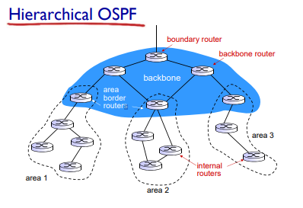
* Hierarchical OSPF
  + two-level hierarchy: local area, backbone.
    - • link-state advertisements only in area
    - • each nodes has detailed area topology; only know direction (shortest path) to nets in other areas.
  + area border routers: “summarize” distances to nets in own area, advertise to other Area Border routers.
  + backbone routers: run OSPF routing limited to backbone.
  + boundary routers: connect to other AS’es.
* Internet inter-AS routing: BGP
  + BGP (Border Gateway Protocol): the de facto inter-domain routing protocol
    - • “glue that holds the Internet together”
  + BGP provides each AS a means to:
    - • eBGP: obtain subnet reachability information from neighboring ASes
    - • iBGP: propagate reachability information to all ASinternal routers.
    - • determine “good” routes to other networks based on reachability information and policy
  + allows subnet to advertise its existence to rest of Internet: “I am here”
* 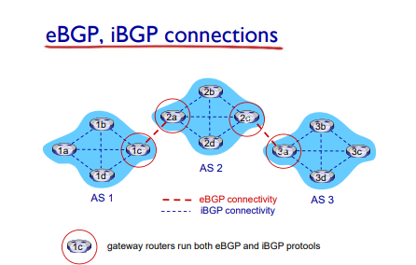
* BGP Basic
  + BGP session: two BGP routers (“peers”) exchange BGP messages over semi-permanent TCP connection:
    - • advertising paths to different destination network prefixes (BGP is a “path vector” protocol)
  + when AS3 gateway router 3a advertises path AS3,X to AS2 gateway router 2c:
    - • AS3 promises to AS2 it will forward datagrams towards X
  + 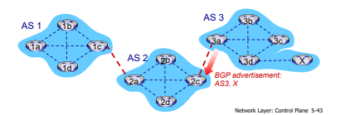
* Path attributes and BGP Routes
  + advertised prefix includes BGP attributes
    - • prefix + attributes = “route”
  + two important attributes: •
    - AS-PATH: list of ASes through which prefix advertisement has passed
    - NEXT-HOP: indicates specific internal-AS router to next-hop AS
  + Policy-based routing:
    - gateway receiving route advertisement uses import policy to accept/decline path (e.g., never route through AS Y).
    - AS policy also determines whether to advertise path to other other neighboring ASes
* BGP Path Advertisement
  + 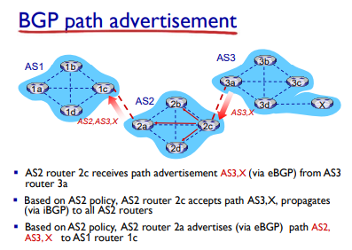
  + 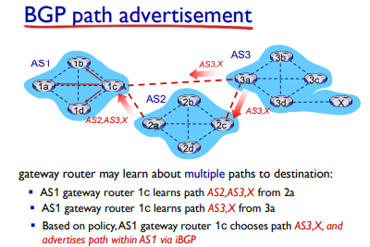
* BGP Messages
  + BGP messages exchanged between peers over TCP connection
  + BGP messages:
    - OPEN: opens TCP connection to remote BGP peer and authenticates sending BGP peer
    - UPDATE: advertises new path (or withdraws old)
    - KEEPALIVE: keeps connection alive in absence of UPDATES; also ACKs OPEN request
    - NOTIFICATION: reports errors in previous msg; also used to close connection
* BGP,OSPF, forwarding table entries
  + 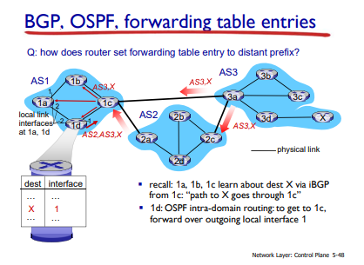
* 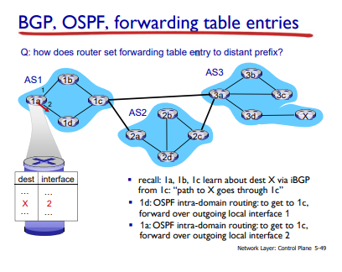
* BGP Route Selection
  + router may learn about more than one route to destination AS, selects route based on:
  + 1. local preference value attribute: policy decision
  + 2. shortest AS-PATH
  + 3. closest NEXT-HOP router: hot potato routing
  + 4. additional criteria
* Hot Potato Routing
  + 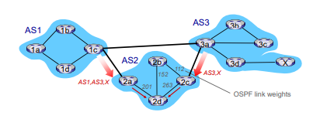
  + 2d learns (via iBGP) it can route to X via 2a or 2c
  + hot potato routing: choose local gateway that has least intradomain cost (e.g., 2d chooses 2a, even though more AS hops to X): don’t worry about inter-domain cost!
* BGP: Achieving policy via Advertisements
  + 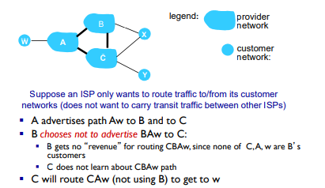
* 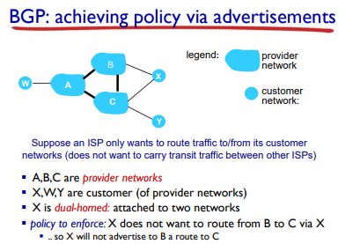
* Why different Intra-, Inter-AS Routing?
  + policy:
    - inter-AS: admin wants control over how its traffic routed, who routes through its net.
    - intra-AS: single admin, so no policy decisions needed
  + scale:
    - hierarchical routing saves table size, reduced update traffic
  + performance:
    - intra-AS: can focus on performance
    - inter-AS: policy may dominate over performance